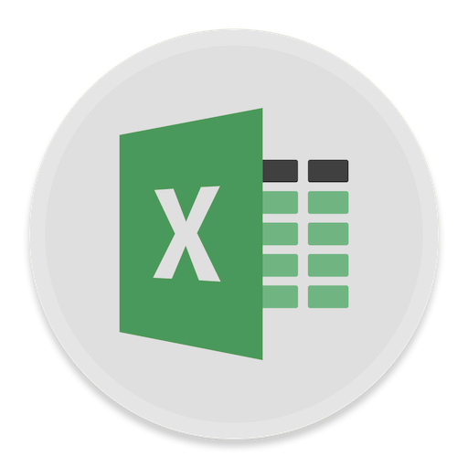

Excel 2016

Processing Data
  - Course objectives:
- Use conditional formatting effectively
- Use IF and VLOOKUP functions for data analysis
- Use PivotTables for flexible data presentation
- Use Sort and filter effectively

Student Training and Support
Phone: |  | (07) 334 64312
Email: |  | askus@library.uq.edu.au
Web: |  | https://web.library.uq.edu.au/library-services/training/
Service Points
St Lucia: |  | Main desk of the SSAH, ARMUS and DHESL libraries
Hospitals: |  | Main desk of the PACE, Herston and Mater libraries
Gatton: |  | Level 2, UQ Gatton Library
Staff Training (Bookings)
Phone |  | (07) 3365 2666
Email |  | staffdev@uq.edu.au
Web |  | http://www.uq.edu.au/staffdevelopment
Staff may contact their trainer with enquiries and feedback related to training content. Please contact Staff Development for booking enquiries or your local I.T. support for general technical enquiries.

Table of Contents
Relative & Absolute Cell References 3
Exercise 1. Relative cell references 3
Exercise 2. Absolute cell references 3
Date Calculations and Conditional Formatting 4
Exercise 3. Date calculations 4
Exercise 4. Apply conditional formatting 4
Exercise 5. Apply conditional formatting to a whole row 5
‘IF’ Function 6
Exercise 6. Using ‘IF’ statements 6
Exercise 7. Practice Exercise Basic IF Statements 6
VLookup Function 7
Exercise 8. Using V lookup 7
Exercise 9. Practice Exercise Vlookup 8
Pivot Table 8
Exercise 10. Create a pivot table 8
Exercise 11. Add data to PivotTable 10
Exercise 12. Edit PivotTable 10
Pivot Table Slicers 11
Exercise 13. Practice Exercise Pivot Table Exercise 12
Exercise 14. Create a PivotChart 13
Extras Sorting & Filtering Lists 14
Exercise 15. Sort by single criteria 14
Exercise 16. Sort by multiple criteria 14
Exercise 17. Filtering with AutoFilter 15
Exercise 18. Progressive filtering 16
Find Unique Values and Remove Duplicates 16
Exercise 19. Find unique values 16
Protection 17
Exercise 20. Worksheet protection 17
Exercise 21. Unprotected cells 18
Goal Seek 19
Exercise 22. Use ‘Goal Seek’ tool 19
Naming Cells 20
Exercise 23. Naming cells via ribbon 20
Answers 20

Exercise document:
Go to https://web.library.uq.edu.au/library-services/training/training-resources and click Excel. Locate and click the Manipulating Data.xlsx link. Make sure you are on the Relative and Absolute Reference sheet when the workbook opens.

Relative & Absolute Cell References
- Relative cell references
Calculate “% Paid”
- Select cell M2  - Type in =L2/K2  - Press Enter  Note: The numerator and denominator can also be inserted with a mouse click on the required cells. | 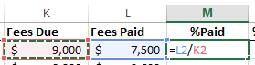
- Select cell M2  - Select the % button from the Number group on the Home tab  - Set 2 decimal places by clicking the “Increase Decimal” button | 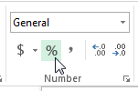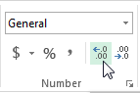
- Use the Autofill tool to fill the remaining results in the column.  Note: this will also carry down the % formatting. | 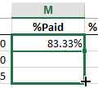

- Absolute cell references
Absolute cell references – This uses the exact address of a cell regardless of the position of the cell that contains the formula.

Calculate % of Total Fees Paid  - Select cell N2  - Type in =L2/L28  - Click the % button  - Click the increase decimals button  - Use the AutoFill tool to fill the remaining results  Note: an error will display as Excel will use relative cell references by default. To correct this the dividing cell reference should be a fixed cell or an absolute reference |  | 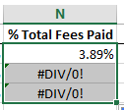
- Edit formula in cell N2 by double clicking.  - Click in L28 cell reference  - Use the function key F4 to change the formula to an absolute reference =L2/$L$28 | 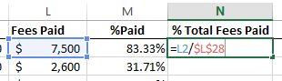
- Use AutoFill to calculate the remaining results | 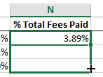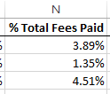

Date Calculations and Conditional Formatting
- Date calculations
Display hidden data
- Select column D and column F  - Right click on selection  - Select Unhide | 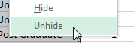
Calculate Age from Date of Birth
Note: Subtracting a date of birth from the current date will display the number of days between the two dates. To find out the age in years, divide by 365.25 (the .25 allows for leap years).
- Select cell E2  - Type in formula ….  =ROUNDDOWN((TODAY()-D2)/365.25,0)  - Press Enter  - Use the AutoFill tool to calculate the remaining results. | 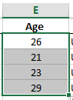
Note: The Rounddown function has the following structure. =Rounddown(number,num_digits). In the above formula the number portion is generated by the formula (TODAY()-d2)/365.25. The num_digits portion is designated zero meaning all the values after the decimal round down to zero e.g. 28.96 becomes 28.00.
- Apply conditional formatting
Apply formats to students over 26 years  - Select range to be formatted:E2:E27  - Select the Conditional Formatting button from the Styles group on the Home tab  - Hover over Highlight Cell Rules  - Select Greater Than… |  | 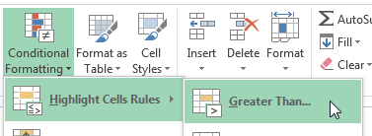
- Type in 26  - Adjust formats to suit  - Click OK | 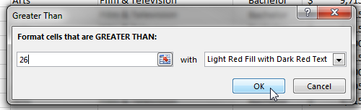
- Apply conditional formatting to a whole row
Apply formats to students over 26 years

- Select range to be formatted:A2:N2
- Select the Conditional Formatting button from the Styles group on the Home tab
- Select New Rule…

- Select “Use a formula to determine which cells to format”  - Enter =$E2>26  Note: This makes the column reference an absolute reference which means the condition will always be based on the content of that column but on a range of rows  - Click the Format… button  - Apply formatting as required  - Click OK  - Click on OK | 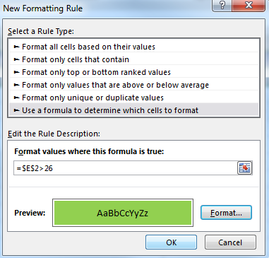
- Select Manage Rules | 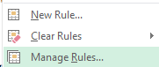
- Go to the Applies To field  - Change the range to $A$2:$N$27  Note: This will ensure the conditional formatting criteria will apply to all rows in the defined range  - Click on OK | 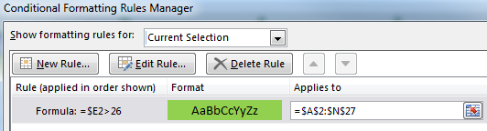

Data Analysis
Excel can analyse a specified range of data using a variety of tools and can subsequently display results calculated from a formula or from user specified options

‘IF’ Function
The IF function will analyse data and provide results defined by the user. The analysis returns either a true or false answer. The displayed results can be text or calculated values. Average and Final Exam grades will analyse exam results and provide a grade for students based on pre-defined criteria.
- Using ‘IF’ statements
Go to the If Statement sheet

- Select cell D2
- Enter formula =IF(C2>=B2,C2*2%,0)
- Select cell E2
- Enter formula =IF(D2>=300,”Excellent”,”Poor”)
- Copy the answers down the columns

- Practice Exercise Basic IF Statements

Go to the Basic If Exercise sheet.
- Follow the instructions below the table
- Create the Average (Overall Score) and IF (Final Grade) statements in their respective columns
- Copy the answers down the columns
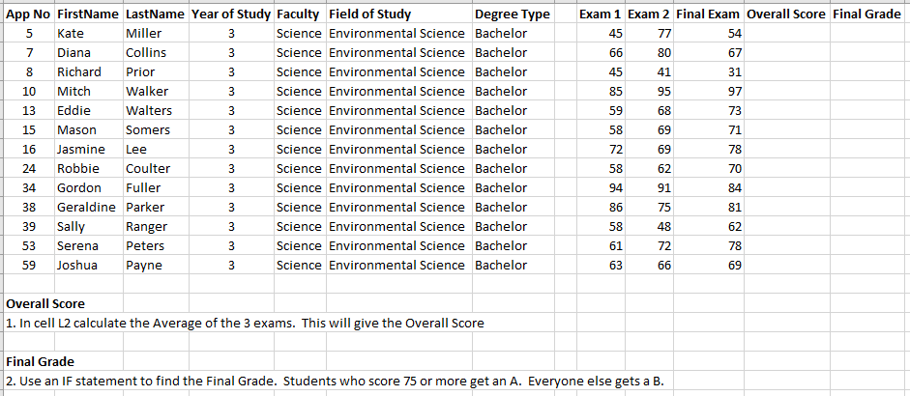
See page 20 for the answer.

VLookup Function
You can also use the VLOOKUP function as an alternative to the IF function for elaborate tests. Lookup functions will analyse data and compare it against a predefined range prior to displaying the result. This works on the principle:
- Here's a value.
- Go to another location and find a match for my value,
- When a match is found show the cell contents from within a specified column number
A vertical array (or table) has headings in the first row and data in column beneath. This is the most common layout for information within Excel.
Note: If the Headers are in the first column and the data is in rows then you would use the HLookup function.
- Using V lookup
Use VLOOKUP to extract data from tables of information
- Go to the “Vlookup” sheet  - Go to cell E22  - Click the Insert Function button on the formula bar | 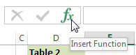
- Type VLOOKUP  - Click Go  - Select VLOOKUP  - Click OK | 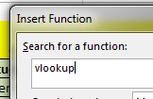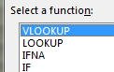
- Enter the Name VLOOKUP function as:  - The cell to check (Lookup_value): D22  - The range to compare (Table_array): D4:M17  - Column containing information (Col_index_num): 2  - Exact or Approximate match (Range_lookup): False (exact)  - Select cell F22  - Enter the Overall Score VLOOKUP function as:  - The cell to check (Lookup_value): D22  - The range to compare (Table_array): D4:M17  - Column containing information (Col_index_num): 10  - Exact or Approximate match (Range_lookup): False (exact)  - Select cell G22  - Enter the data opposite into the Table 1 area on the spreadsheet  - Enter the Final Grade VLOOKUP function as:  - The cell to check (Lookup_value): F22  - The range to compare (Table_array): A4:B9  - Column containing information (Col_index_num): 2  - Exact or Approximate match (Range_lookup): True (range)  - AutoFill down | 1  2  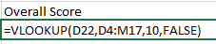  3  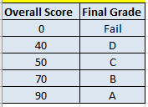  4
Note: As we are looking for an approximate match the data in column 1 of the table array A4:B9 must be sorted in ascending order.
- Practice Exercise Vlookup

Go to the VLookup Exercise sheet.  - Follow the 6 instructions at the top right  - Create a vertical lookup function to extract the name of the currency  - Create a vertical lookup function to display the amount of converted currency.  - See page 20 for the answer. | 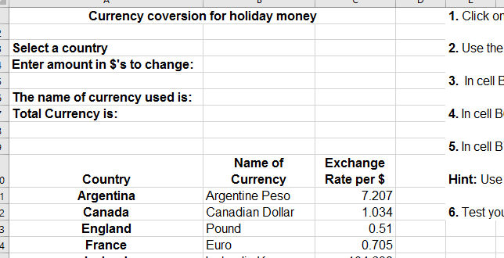

Pivot Table
Pivot tables allow you to extract and arrange elements of your data to present it in an alternative table. With pivot tables you can group and summarise list data into a format that is easy for reporting and analysis. A pivot table won’t automatically update if the raw data changes and you will need to refresh to update any changes in the data.
- Create a pivot table

- Select the Fees PivotTable Data sheet  - Click any individual cell within the data  - Click Insert tab  - Click Pivot Table button | 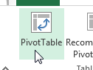
- In the Create Pivot Table dialog box check the correct data range has been selected and entered  - Click on New Worksheet  - Click OK | 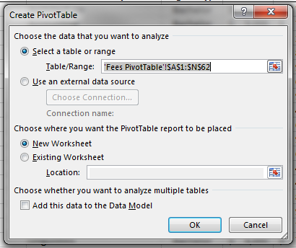
A new worksheet opens  - Rename the worksheet Pivot  The fields available are displayed in the PivotTable Fields List at the right of the screen  Note: These are used to build the PivotTable. |  | 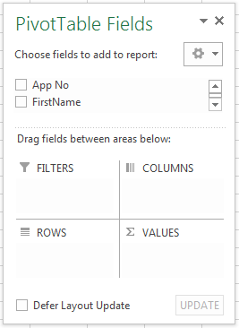

Pivot Table categories define 3 main areas of information:

Filters | Column/Row Labels | Values
Gives an overall view which can be refined | Groups of data:  e.g. Dept, Model, Product Type, Locations, Salespeople | Groups of data: e.g. Amounts

- Add data to PivotTable
To display fees owing in each faculty  Drag & Drop the following fields into the appropriate sections…  - Year of Study into Column section  - Faculty into Rows section  - Fees Owing into Values section  Note 1: The Report Filter allows you to apply filters to the Pivot Table to display select portions only e.g. Filter by Degree Type  Note 2: The PivotTable will automatically reflect changes as you work unless you select “Defer Layout Update.” This allows you to click the “Update” button when complete. | 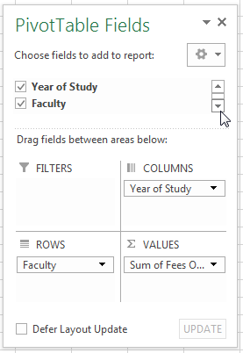
- Edit PivotTable
To rearrange the Pivot Table reposition fields as needed.  - Drag Year of Study from Column to Row  Note: The Pivot Table will adjust to display the new data layout  - Drag Year of Study above Faculty within the Row section | 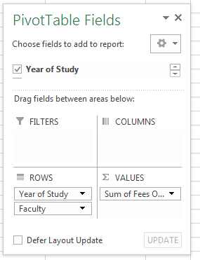

To change Table values displayed  Pivot Tables can display more than one column of data at a time  - Drag Faculty from the Fields List to the Values section  Note: Faculty as a value defaults to Count as it is text  - Drag a second Fees Owing into the Values section | 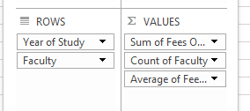
- On the PivotTable Tools; Analyze tab  Click on ‘Field Settings’ in Active Field group | 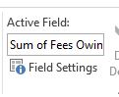
- Click Average function  - Click OK  Note: PivotTable will automatically change to display new summary figures | 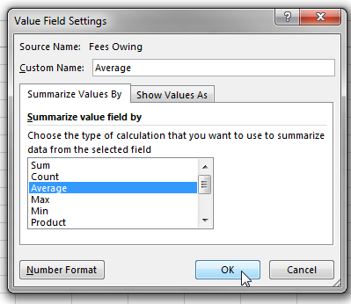

Pivot Table Slicers
Pivot table slicers are a type of filter you can use to display select data within your pivot table quickly and efficiently.

 | - Click Pivot Table Tools - Analyse tab  In the Filter group  - Click Insert Slicer | 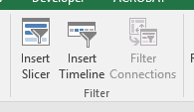
In the Insert Slicers window
- Tick Faculty and Field of Study
- Click OK
 | Clicking a slice will apply a filter to display the choice made  - Click Arts in Faculty slice  - Click Accounting in Field of Study slice | 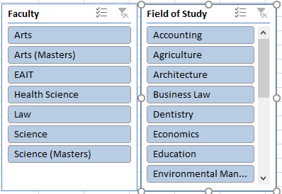

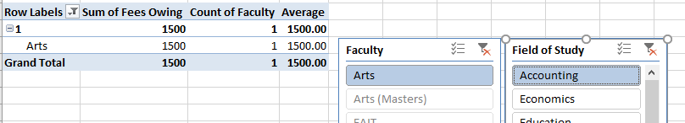

- Remove a slice by clicking the clear filter button in the top right hand corner of the slicer
Choose new slicers to apply if needed

Drill Downs
A drill down is a breakdown of select information contained within a pivot table. It is activated by double clicking on selected data. The drill down displays in a new sheet.

- Find the 4th year law student  - Double click the Fees Owing value  Note: a new worksheet opens and the displayed data is not connected to the original data sheet or pivot table.  - Click sheet Fees Pivot Table Data  - Go to App No. 52 – Michelle Dempsey  - Change her Fees Paid value to 14210  - Click Pivot tab  - On the PivotTable Tools; Analyze tab  - Click Refresh  Note: Data for 4th year law should now read 0  - Click Sheet 1 tab  Note: Data has not updated | 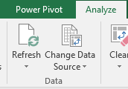  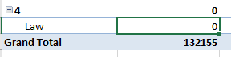
- Practice Exercise Pivot Table Exercise

Click Pivot Table Exercise tab
Insert a pivot table onto the green cell (J3) using the following layout to calculate the displayed values
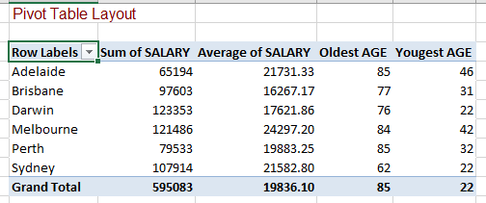
- Create a PivotChart
To add a PivotChart  - Click Pivot tab  - Select a cell in the PivotTable to activate  - Go to Options Tab  - Select PivotChart button | 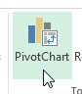
- Select a column chart
- Click on OK
Note: The PivotTable Field List is available as a filter pane for the Pivot Chart. It offers Legend Fields and Axis Fields to edit the chart data displayed. This will also adjust the Pivot Table it is connected to. | 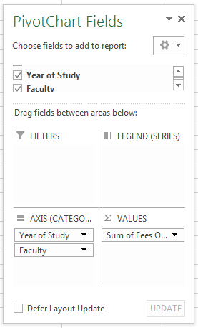

Extras
Sorting & Filtering Lists
- Sort by single criteria
Go to the Sort & Filter worksheet tab

To sort data by Date of Birth  - Click in the Date of Birth column  - On the Home tab  - Go to the Editing group  - Click the Sort & Filter button  - Select the date order ‘Oldest to Newest’ | 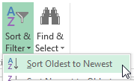
To sort data by another criteria  - Click in any cell in App No column  - On the Home tab  - Go to the Editing group  - Click the Sort & Filter button  - Select sort order “Sort Smallest to Largest”  Note: If you had selected data that was recognised as text the option would be “Sort A to Z” | 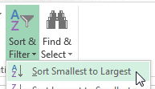
- Sort by multiple criteria
To sort by Faculty, Field of Study then Year  - On the Home tab  - Click Sort & Filter button  - Select Custom Sort…  Note: The sort window will appear to add levels and criteria to sort the data. |  | 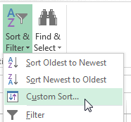
- Click the down arrow to sort by…  - Select Faculty (A to Z)  - Click on the Add level button  - Click the down arrow beside Then by  - Select Field of Study (A to Z)  Note: The data will be sorted according to the criteria entered. | 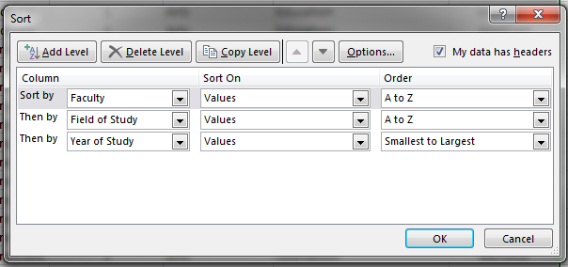

Sorting Data allows you to present it in a specified order. If you want to temporarily hide or extract data use the filtering tool available from AutoFilter.
- Filtering with AutoFilter

To activate AutoFilter  - Go to the Home tab  - Click Sort & Filter  - Select Filter  Note: All columns will have an AutoFilter arrow in the heading cell. | 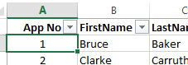
To filter for one Field of Study  - Click on column AutoFilter arrow  - Clear tick beside Select All  - Select Dentistry  Note: All data is filtered to display records matching the criteria.  To remove filter  - Click AutoFilter arrow  - Click Select All  - Click OK | 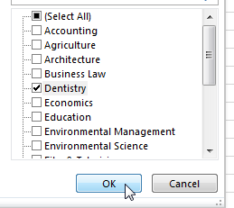
To filter for Year 2 - Year of Study  - Click on column AutoFilter arrow  - Clear tick beside Select All  - Select 2 | 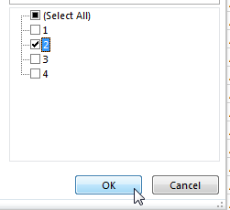
Note: All data is filtered to display only records matching the criteria
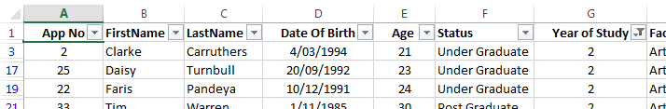
To remove filter:  - Click Sort & Filter button  - Select Clear |  | 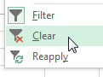
- Progressive filtering
To filter data for Undergraduates in their first year studying Arts  - Click on Status AutoFilter arrow  - Clear tick beside Select All  - Select Undergraduate  - Click Year of Study AutoFilter arrow  - Clear tick beside Select All  - Select 1  - Click on Faculty AutoFilter arrow  - Clear tick beside Select All  - Select Arts | 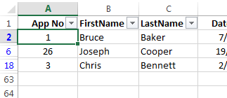
To remove all filters  - Go to Home tab  - Click Sort & Filter button  - Select Clear |  | 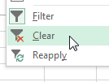
To switch AutoFilter off  - Go to Home tab  - Click Sort & Filter button  - Select Filter  Note: This is a toggle option, if AutoFilter is on it will be switched off. |  | 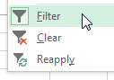

Find Unique Values and Remove Duplicates
- Find unique values
Go to Remove Duplicates sheet

To Find Unique Values  - Sort by App No column  - Go to Data tab  - Click Advanced button in Sort and filter group | 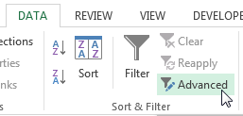
- Check List Range = ($A$1:$J$86)  - Click Unique records only  - Click OK | 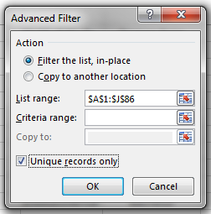
To Remove Duplicates  - Go to Data tab  - Click Remove Duplicates button in Data Tools group | 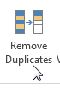
To remove Filter
- Go to Data tab
- Click Clear button in Sort and filter group

Protection
To prevent a user from accidentally or deliberately changing, moving, or deleting important data from a worksheet or workbook, you can protect certain worksheet or workbook elements, with or without a password.
- Worksheet protection
If you protect a worksheet; all cells will be locked by default. Users cannot make any changes to a locked cell. For example, they cannot insert, modify, delete, or format data in a locked cell.
To Protect a worksheet  - Go to Home tab  - In the Cells group  - Click Format  - Select Protect Sheet… | 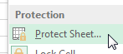
Note: You will not be able to change any of the cells in the worksheet when protection is on. A password can be entered for further security. | 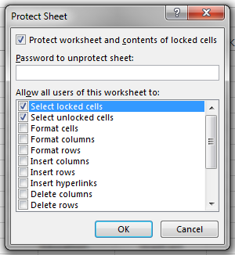
To turn off Protection  - Go to Home tab  - In the Cells group  - Click Format  - Select Unprotect Sheet | 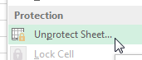
- Unprotected cells
Excel protects all cells that are locked. All cells are locked by default, so when protection is applied all cells are unavailable. To enabling editing, cells must be unlocked before they are protected.
Selective Protection: Unlock Cells  - Select the cells you want users to be able to change - “Remove Duplicates” (K1:K4)  - Go to the Home tab  - Click the Format button  - Select Lock Cell  Note: This will “unlock” the selected cells. When protection is applied these cells will still be accessible | 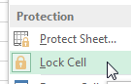
Selective Protection: Apply Protection:
- Go to Home tab
- In the Cells group
- Click Format
- Select Protect Sheet
- Click OK
Note: the unlocked cells K1:K4 can be edited but the remainder of cells are protected.

Goal Seek
If you know the result that you want from a formula, but are not sure what input value the formula needs to get that result, use the Goal Seek feature. This feature will change the actual values on a spreadsheet.
- Use ‘Goal Seek’ tool
Select the Relative and Absolute Reference worksheet and select cell M2.  Calculate how much of the fees due should be paid to reach 92.25% of the total.  - Click on Data tab  - Click What if Analysis button  - Select Goal Seek | 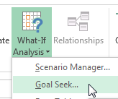
- Enter the Set cell reference – M2  Note: Set cell must have a formula  - Type in the result you want – 92.25%  Note: % sign is essential or alternative enter 0.9225  - Enter Changing cell reference - $L$2  Note: Changing cell must NOT have a formula | 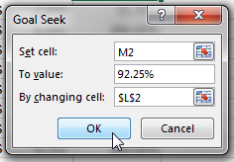
- Click OK  Note: Goal Seek will provide a solution in a dialog box for acceptance or rejection  - Click OK again to accept. | 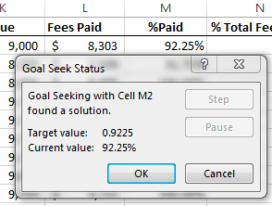

Naming Cells
Naming cells or ranges allows you to use those names in formulas. This has the same effect as making a cell or range absolute. See Exercise 2 on page 3 for further information on absolute cell references.
Note: Cell/Range names cannot have any spaces. They must start with a letter and can have numbers but they cannot be the same as a cell reference or a function name. E.g. You cannot use SUM or A1 as a cell/range name but you could use AAAA1 or SUM111 if you wish.

- Naming cells via ribbon
To name a range  - Go to Fees PivotTable worksheet  - Select range - (A1:N62)  - Click Formulas tab  - Click Define Name  - Select Define Name… | 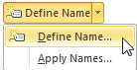
Note: Excel will automatically insert a name from an adjacent cell if available.  - Enter a name for the range e.g. Data  - Click OK | 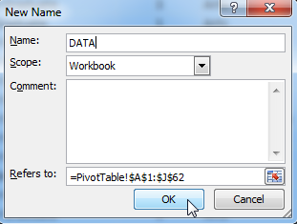

Answers

Basic If Exercise:
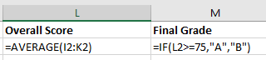

Vlookup Exercise

